MARKETING

1. TARGETING YOUNG MEN



2. TARGETING YOUNG WOMEN



3. USING A PENETRATION STRATEGY



4. ADVERTISING A LOCAL PRODUCT



5. ADVERTISING A NATIONAL BRAND



6. USING UNDIFFERENTIATED STRATEGY



7. USING EXCLUSIVE DISTRIBUTION

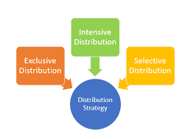

8. TARGETING A YOUNG MAN



9. TARGETING A YOUNG WOMEN



10. TARGETING A WOMEN



***Anmol vig***